Assignment 3 – Inheritance (Clark University Student Application)

This report documents a Windows Forms application that models four student categories (Part-Time, Undergraduate, Graduate, PhD) via inheritance. A shared Student base type centralizes identity/contact data and letter-grade mapping, while each subclass overrides CalculateAverage() to encode its weighting policy. A Template Method exposes both ComputeAverage() (numeric) and ComputeGrade() (letter) to the UI. Inclusive thresholds ensure boundary correctness (e.g., 90.0 -> A+).

Inheritance Design
- Base Class – Student
  - Common fields: firstName, lastName, test1, test2, street, city, telephone.
  - Grading pipeline:
    - CalculateAverage() – abstract in base, implemented by each subclass with its weights.
    - ComputeAverage() – public numeric result used by the UI.
    - ComputeGrade() – maps the numeric average to a letter using one centralized scale.
- Derived Classes
  - PartTimeStudent: adds ssNum.
  - UnderGradStudent: adds id.
  - GradStudent: adds id, thesis.
  - PhDStudent: adds id, phDAdvisor, dissertation.

Grade Computation Logic
Each subclass overrides CalculateAverage() with the assignment’s weights:
Student Type | Formula
PartTimeStudent | 0.4 * test1 + 0.6 * test2
UnderGradStudent | 0.45 * test1 + 0.55 * test2
GradStudent | 0.35 * test1 + 0.65 * test2
PhDStudent | 0.3 * test1 + 0.7 * test2

Letter Grade Scale
After computing the numeric average, the app assigns a letter using inclusive boundaries:
- A+ for avg ≥ 90
- A for 85 ≤ avg < 90
- B+ for 80 ≤ avg < 85
- B for 75 ≤ avg < 80
- C+ for 70 ≤ avg < 75
- C for 65 ≤ avg < 70
- D for 60 ≤ avg < 65
- F for avg < 60
Note: Boundaries are inclusive (e.g., 90.0 is A+).

UI Workflow
- Type selection. The form toggles visibility of type-specific inputs (SSN, ID, Thesis, Advisor, Dissertation) to minimize entry errors.
- Data entry. Users provide name, two test scores (0–100), and address (street, city, telephone).
- Real-time feedback. On score changes, the UI constructs a temporary instance of the selected type and calls ComputeAverage() and ComputeGrade(). The Grade field shows "<average> (<letter>)".
- Commit. On Add, the form validates inputs, materializes the correct subclass, and appends it to the collection/view.
End-to-End Example
- Selection: Part-Time; Scores: 85 and 92.
- Domain: PartTimeStudent.CalculateAverage() applies 0.4×85 + 0.6×92 = 89.2.
- Mapping: Base class converts 89.2 → A (85 ≤ 89.2 < 90).
- UI displays 89.2 (A).

Validation Rules
- Scores must be numeric 0–100.
- Identifiers:
  - Part-Time -> SSN required.
  - Undergrad/Grad/PhD -> ID required.
- Grad -> Thesis required.
- PhD -> PhD Advisor and Dissertation required.
- Basic contact -> street, city, telephone required.

Sample Runs & Outputs
Sample 1 – Part-Time
Input
- Name: John Doe
- Type: Part-Time
- SSN: 123-45-6789
- Test1: 85, Test2: 92
- Address: 123 Main St, Worcester, 508-555-0123
Computation
- Average = 0.4*85 + 0.6*92 = 34 + 55.2 = 89.2
- Letter = A (since 85 ≤ 89.2 < 90)
Displayed Grade: 89.2 (A)
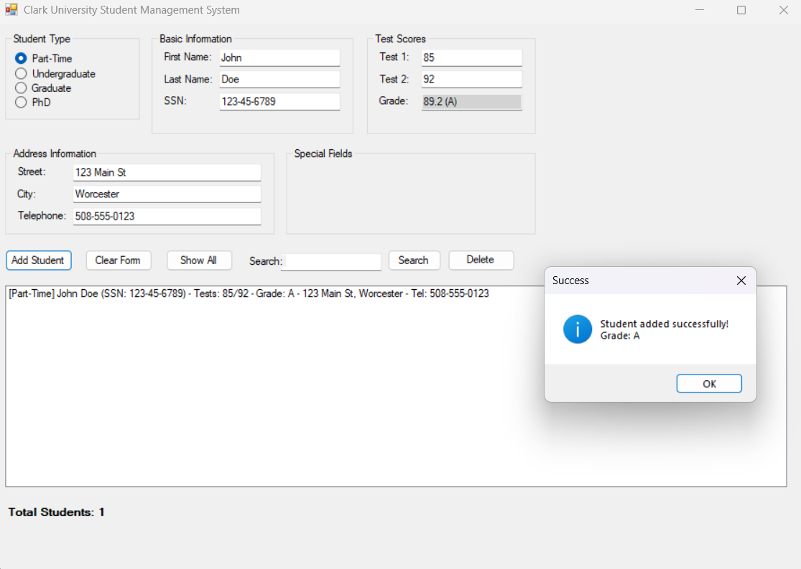
Sample 2 – PhD Student
Input
- Name: Jane Smith
- Type: PhD Student
- ID: 888-2025-001
- PhD Advisor: Dr. Allen
- Dissertation: Autonomous Systems
- Test1: 88, Test2: 94
- Address: 9 Clark Ave, Worcester, 508-555-0456
Computation
- Average = 0.3*88 + 0.7*94 = 26.4 + 65.8 = 92.2
- Letter = A+ (since 92.2 ≥ 90)
Displayed Grade: 92.2 (A+)
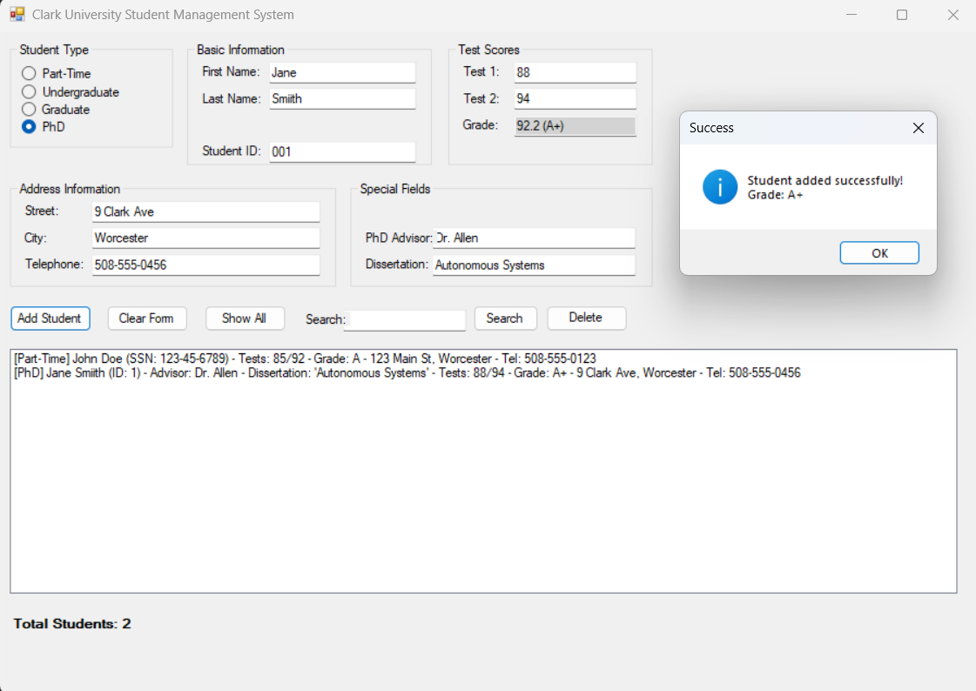

Boundary Case – Exactly 90.0
Example (Part-Time): test1 = 95, test2 = 87.5
- Average = 0.4*95 + 0.6*87.5 = 38 + 52.5 = 90.0
- With inclusive thresholds, 90.0 → A+.
If thresholds were exclusive (>), 90.0 would have produced A. The app uses inclusive rules to avoid ambiguity.

Requirements -> Implementation (Traceability)
Requirement | Where implemented
PartTimeStudent with ssNum and formula 0.4/0.6 | PartTimeStudent.CalculateAverage(); UI shows SSN field
UnderGradStudent with id and formula 0.45/0.55 | UnderGradStudent.CalculateAverage(); UI requires ID
GradStudent with id, thesis and formula 0.35/0.65 | GradStudent.CalculateAverage(); UI requires ID + Thesis
PhDStudent with id, phDAdvisor, dissertation and formula 0.3/0.7 | PhDStudent.CalculateAverage(); UI requires ID + Advisor + Dissertation
Shared scale for letter grades | Student.CalculateLetterGrade()
Real-time preview in UI | Score change handler → build temp object → ComputeAverage/ComputeGrade()
Validation of fields | UI validation before Add/Save

Key Methods Summary
Base class: Student
public abstract class Student
{
// Common identity/contact + scores
protected string firstName = string.Empty;
protected string lastName = string.Empty;
protected double test1;
protected double test2;
protected string street = string.Empty;
protected string city = string.Empty;
protected string telephone = string.Empty;

// Each subclass supplies its own weighting
protected abstract double CalculateAverage();

// Numeric average used by the UI
public double ComputeAverage()
{
return CalculateAverage();
}

// Maps numeric average to a letter once, in the base class
public string ComputeGrade()
{
var average = CalculateAverage();
return CalculateLetterGrade(average);
}

// Inclusive thresholds (e.g., 90.0 => A+)
protected string CalculateLetterGrade(double average)
{
if (average >= 90) return "A+";
else if (average >= 85) return "A";
else if (average >= 80) return "B+";
else if (average >= 75) return "B";
else if (average >= 70) return "C+";
else if (average >= 65) return "C";
else if (average >= 60) return "D";
else return "F";
}
}

Example override: PartTimeStudent
public sealed class PartTimeStudent : Student
{
public string ssNum { get; set; } = string.Empty;

// 0.4 * test1 + 0.6 * test2
protected override double CalculateAverage()
{
return 0.4 * test1 + 0.6 * test2;
}

public override string ToString()
{
// Show numeric + letter for clarity in lists
return $"{firstName} {lastName} - Grade: {ComputeAverage():0.##} ({ComputeGrade()})";
}
}

Additional Override Snippets
UnderGradStudent
public sealed class UnderGradStudent : Student
{
public int Id { get; set; }

// 0.45 * test1 + 0.55 * test2
protected override double CalculateAverage()
{
return 0.45 * test1 + 0.55 * test2;
}
}
GradStudent
public sealed class GradStudent : Student
{
public int Id { get; set; }
public string Thesis { get; set; } = string.Empty;

// 0.35 * test1 + 0.65 * test2
protected override double CalculateAverage()
{
return 0.35 * test1 + 0.65 * test2;
}
}
PhDStudent
public sealed class PhDStudent : Student
{
public int Id { get; set; }
public string PhDAdvisor { get; set; } = string.Empty;
public string Dissertation { get; set; } = string.Empty;

// 0.3 * test1 + 0.7 * test2
protected override double CalculateAverage()
{
return 0.3 * test1 + 0.7 * test2;
}
}

Key UI Code Snippets

Real-time Grade Preview (as user types scores)
private void CalculateGradePolymorphically()
{
if (!double.TryParse(txtTest1.Text, out var t1)) return;
if (!double.TryParse(txtTest2.Text, out var t2)) return;

Student temp = CreateStudentFromForm(t1, t2);
if (temp == null) { txtGrade.Text = string.Empty; return; }

double avg = temp.ComputeAverage();
string letter = temp.ComputeGrade();
txtGrade.Text = $"{avg:0.##} ({letter})";
}

Factory: Create the Correct Subclass Based on Selected Type
private Student? CreateStudentFromForm(double t1, double t2)
{
string first = txtFirstName.Text.Trim();
string last = txtLastName.Text.Trim();
string street = txtStreet.Text.Trim();
string city = txtCity.Text.Trim();
string tel = txtTelephone.Text.Trim();

if (rbPartTime.Checked)
{
var ssn = txtSSN.Text.Trim();
return new PartTimeStudent { firstName = first, lastName = last, street = street, city = city, telephone = tel, ssNum = ssn, test1 = t1, test2 = t2 };
}
if (rbUndergrad.Checked)
{
int.TryParse(txtID.Text, out int id);
return new UnderGradStudent { firstName = first, lastName = last, street = street, city = city, telephone = tel, Id = id, test1 = t1, test2 = t2 };
}
if (rbGrad.Checked)
{
int.TryParse(txtID.Text, out int id);
string thesis = txtThesis.Text.Trim();
return new GradStudent { firstName = first, lastName = last, street = street, city = city, telephone = tel, Id = id, Thesis = thesis, test1 = t1, test2 = t2 };
}
if (rbPhD.Checked)
{
int.TryParse(txtID.Text, out int id);
string advisor = txtAdvisor.Text.Trim();
string diss = txtDissertation.Text.Trim();
return new PhDStudent { firstName = first, lastName = last, street = street, city = city, telephone = tel, Id = id, PhDAdvisor = advisor, Dissertation = diss, test1 = t1, test2 = t2 };
}
return null;
}

Class Hierarchy
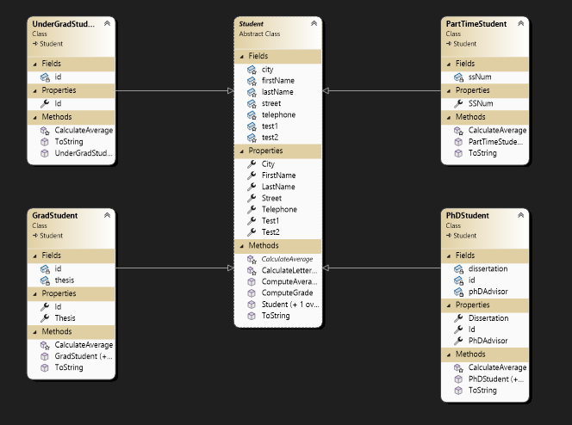

File Structure (source files)
- Student.cs – base class with template (CalculateAverage(), ComputeAverage(), ComputeGrade() + inclusive letter scale)
- PartTimeStudent.cs – 0.4/0.6 override
- UnderGradStudent.cs – 0.45/0.55 override
- GradStudent.cs – 0.35/0.65 override
- PhDStudent.cs – 0.3/0.7 override
- Form1.cs – WinForms logic (event handlers, validation, factory, live preview)
- Form1.Designer.cs – WinForms layout and control declarations

